SRI SHANKAR R
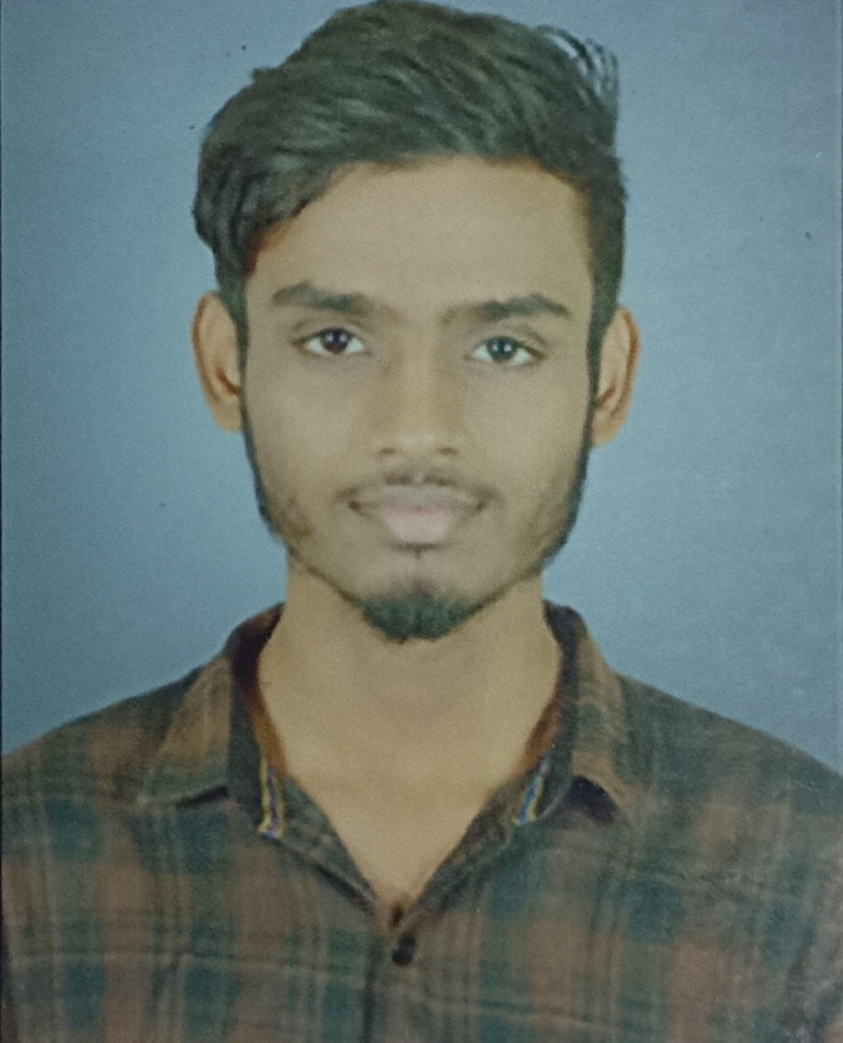
L5/57,TNHB Colony,
Railar Nagar,Madurai-18.
srishankar2602@gmail.com
https://www.linkedin.com/in/sri-shankar-r-620453200/
https://github.com/srishankar2602
+91 6382738633.

.
CAREER OBJECTIVE
As an enthusiastic fresher eager to contribute to team success through hard work, attention to detail and excellent organizational skills. Motivated to learn, grow and excel as a software developer or a Game developer in a reputed software company.
ACADEMIC DETAILS
Course : BACHELOR OF ENGINEERING – COMPUTER SCIENCE
Institution : Ramco Institute of Technology, Rajapalayam.
Period : 2018-2022 CGPA: 7.45(up to 5th sem.)

Course : HIGHER SECONDARY SCHOOL

Institution : C.E.O.A Hr. Sec School, Madurai.
Period : 2017 – 2018 Percentage: 80%

Course : SECONDARY SCHOOL LEAVING CERTIFICATE
Institution : C.E.O.A Hr. Sec School, Madurai
Period : 2015– 2016 Percentage: 91%

AREAS OF INTEREST
- OOPS
- Data Structure
- Game Development

TECHNICAL SKILLS
- Languages known : C, JAVA, Python (Basics), HTML, JavaScript.
- Databases known : MYSQL
- IDE : Eclipse, Android Studio, NetBeans,Unity3D
- Operating System : Windows, Linux

PROJECTS UNDERTAKEN
Project I : Student Election
Front end : Java Swing
Back end : MYSQL
Description : To develop an application which helps to conduct a student role elections such as class representative.
Project II : CGPA Calculator
Front end : Java Swing
Back end : MYSQL
Description : The main objective of this project is to develop an application which systemize the CGPA calculations.
Project III : E-Book Management System
Front end : Java Swing
Back end : MYSQL
Description : It is an application in which users can buy or rent E-books through online.
Project IV : Social Media
Front end : Android Studio
Back end : Sqlite
Description : The objective of this project is to create a Social Media Application which enable users to upload and view memes.

Project V : Screw Defect Detecting System
Description :A machine learning project to systemize the defected screw detection in an industry using YOLO algorithm.

ONLINE COURSES
- Coursera - SQL for Data Science, Introduction to Game Designing
- TCS - Career Edge-Knockdown the Lockdown
- Cognitive Class - Introduction to Data Science
- Datacamp – Data science for Everyone.
- Udemy – PHP for beginners, After effects-motion graphics.

INTERNSHIP:
- Internship in “Machine Learning using Python” offered by ISSDC.

CO – CURRICULAR ACTIVITIES

- Paper presentation on “E-Ball Technology” in Paavai Institute of Technology, Namakkal.
- Completed Value Added Course in “Java Programming” and “Web Designing”.
- Attended Workshop “Web Designing and App Development” in TCE, Madurai.

INPLANT TRAININGS & INDUSTRIAL VISITS

- Attended Inplant training at Sofia Infology at Madurai in 2018 and gained knowledge about Embedded Systems.
- Visited “Ramco Mills” at Rajapalayam in 2018 and Enthu Technology at Bangalore in 2019 as a part of our industrial visit.

ACHIEVEMENTS:
- Completed "A" Certificate in NCC
- Cadet Leader in NCC.
- Runner-up in “Ball Badminton” Zonal Level
- Won 3rd Prize For "GPA Calculation Project" on National Science Day.
- Member in CSI,NSS.

INTERPERSONAL SKILLS:
- Creativity
- Leadership
- Adoptability
- Team Work

PERSONAL DETAILS:

- Father’s Name : Mr. Rathinavel K
- Mother’s Name : Mrs.S.R.Anitha
- D.O.B. &Age : 26.02.2001 & 20years
- Languages known : Tamil & English
- Hobbies : Meme Creation, Editing, Music.

Place: Madurai
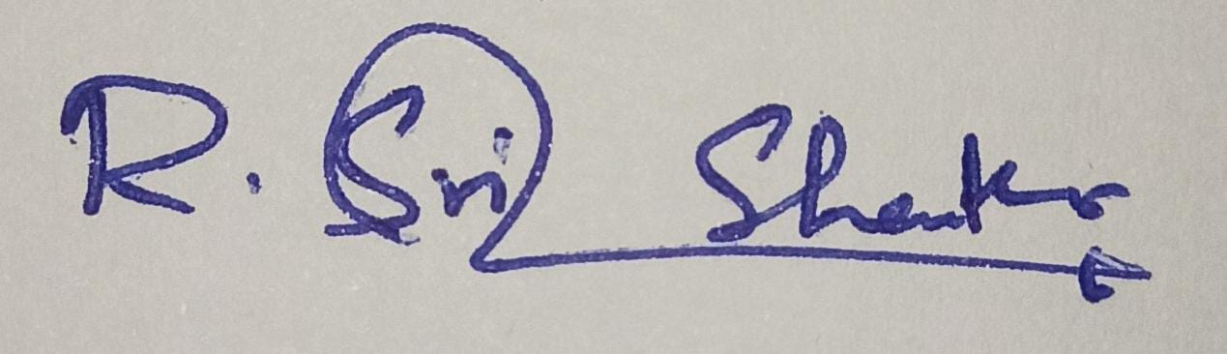 [R.SRI SHANKAR]

